Gantt Chart

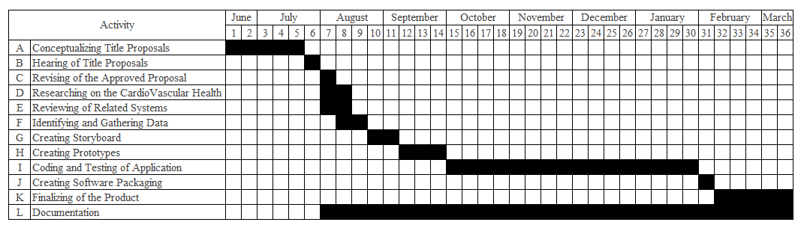

PERT Table

|  |  |  |  |  |  |  |  |  |  |  |
| --- | --- | --- | --- | --- | --- | --- | --- | --- | --- | --- |
| Activity | Predecessor | o | m | p | ET | ES | EF | LS | LF | Slack |
| A | None | 4 | 5 | 6 | 5 | 0 | 5 | 0 | 5 | 0 |
| B | A | 1 | 1 | 1 | 1 | 5 | 6 | 5 | 6 | 0 |
| C | B | 1 | 1 | 1 | 1 | 6 | 7 | 6 | 7 | 0 |
| D | B | 1 | 2 | 3 | 2 | 6 | 8 | 6 | 8 | 0 |
| E | B | 1 | 2 | 2 | 2 | 6 | 8 | 6 | 8 | 0 |
| F | C | 1 | 2 | 3 | 2 | 7 | 9 | 7 | 9 | 0 |
| G | F | 1 | 2 | 3 | 2 | 9 | 11 | 9 | 11 | 0 |
| H | G | 2 | 3 | 4 | 3 | 11 | 14 | 11 | 14 | 0 |
| I | H | 12 | 16 | 18 | 16 | 14 | 30 | 14 | 30 | 0 |
| J | I | 1 | 1 | 1 | 1 | 30 | 31 | 30 | 31 | 0 |
| K | J | 3 | 5 | 6 | 5 | 31 | 36 | 31 | 36 | 0 |
| L | B | 25 | 30 | 33 | 30 | 6 | 36 | 6 | 36 | 0 |

CPM

31

36

31

30

30

14

14

11

11

36

6

8

6

8

6

9

9

7

7

6

6

5

5

0

L

E

F

G

H

I

J

K

D

C

B

A

30v

2

2

5

1

16

3

2

2

1

1

0

0

0

5

Critical Paths: A + B + C + F + G + H + I + J + K = 36 weeks

A + B + L = 36 weeks